Manage Your Lake Impact – Steps You Can Take
Everything you can do makes a difference!

What happens in the entire watershed (Forrest and near lake) can impact the lake. All of the surrounding land within a watershed contributes to the overall health or deterioration of water quality. The key to water quality and aquatic vegetation is reducing the amount of nutrients getting to the lake. Every effort should be to avoid direct water runoff and attempt to have filtered water supplying the lake.

What can you do?
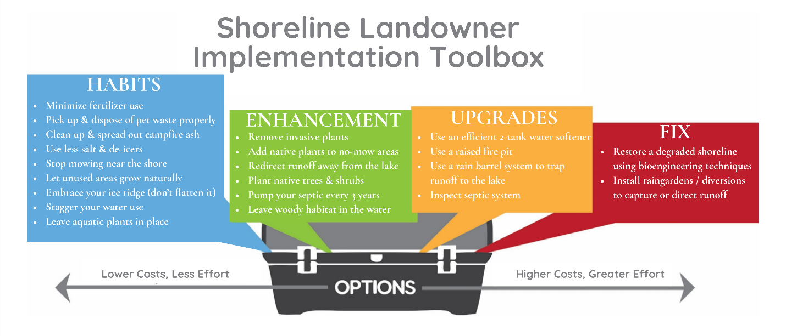
Habits:
- Fertilizer: Do not use fertilizer anywhere on your property.
- Pet waste: Pick it up and dispose in the trash.
- Campfire ash: Keep campfires and ash at least 25 feet from shore. Spread out ash as far away from the lake as possible.
- Winter: use no or less salt and de-icers.
- Grass: reduce the amount and do not mow near the shore.
- Natural setting: let unused areas grow naturally.
- Aquatic plants: leave in place on the shoreline and if trimmed or cut, compost at least 25 feet from shore.
- Boat Speed: SLOW DOWN! Motors churn up the water and can release sequestered phosphorus in the lake bottom which aquatic plants can utilize.
- Garbage: do not burn your garbage.

Enhancement:
- Invasive plants: remove them.
- Native plants: add them to the shoreline or buffer zones.
- Direct water runoff: redirect it though managing zones and plants or creating barriers. Drainage discharge is a major source of phosphorus and nitrates.
- Trees and shrubs: add to the buffer zone in addition to native plants.
- Septic system: at least a 3 year inspection and pumping.
Upgrades:
- Water Softener; use an efficient 2 tank system to reduce water discharge
- Fire Pit: use a raised or sealed fire pit.
- Rain barrels: Use them to trap and reduce runoff

Fix:
- Shoreline: restore a degraded shoreline by using bioengineering techniques and native plants. Not more than 25% of shoreline degraded or developed.
- Direct water runoff: eliminate water flowing directly into the lake and not filtered by aquatic and upland buffer zones.
- Rain gardens: install to capture rain water off impervious surfaces. Use the calculator to determine size. Used to capture or direct rainwater.
- Pervious surfaces: consider using instead of impervious surfaces.
- Vegetation management: participate in spring weed control program. If you cut weeds or rake, compost them at least 25 feet from shore.

